**Minutes of the**

**STATUTORY GENERAL ASSEMBLY**

# Held in Brussels on 1st June 2017

# _____________________________________________________________________

Participants : BORDAT Jacques, FCSIV – GAE President F

CAZES Bertrand, Glass For Europe Secretary-General F

DALTON Dave, British Glass Director UK

DE CLIPPELE Guy, FIV-VGI Executive Manager B

FARRELLY Adeline, FEVE and GAE Secretary-General IE

FAVRY Véronique, GAE Coordinator B

HÜNLICH Thomas, Schott AG - ESGA President D

IBLED Xavier, Arc International – EDG President EDG

MAZZOLINI Peter, Czech Glass Federation President CZ

OVERATH Johann, BV Glas Director – GAE Vice-President D

RIVET Fabrice, Chairman of the EHS Committee B

SAYIN Gizep, Sisecam – TSVCF Turkish Glass Federation TR

ŠKULTÉTY Štefan, Secretary-General Slovak Glass Association (SGA) SK

STAUB Franck, FCVMM Secretary-General F

SWIATEK Jan, Polish Glass President PL

Apologies : BORREANI Ezio, Assovetro Director I/Proxy

JORNS Axel, APFE GlassFibre*Europe* Secretary-General D

KRISSMANEK Alexander, Austrian Glass Federation AT/Proxy

de LAVERGNOLLE , FCVMM President F

RODERO Carlos, Vidrio España ES

VAN VALBURG Marco, VNG (NL) NL

* * * * *

1. **Welcome, roll call of members and approval of the agenda**

The **President** welcomed all participants to this Statutory General Assembly.

He confirmed that the General Assembly had the necessary quorum to deliberate (¾ of membership): 13 members (+ 1 proxy) for 17 voting members.

Members approved the agenda proposed.

1. **Anti-Trust Statement**

Members were reminded to respect the anti-trust laws.

1. **Approval of the minutes of the Statutory General Assembly held on 26 May 2016**

The **President** informed the members that no request for modification had been received on the minutes of the General Assembly held in Brussels on 26 May 2016. In the absence of any written or oral comments, the minutes were unanimously approved.

1. **Report 2016-2017 by the President**

**Mr. Bordat** started his message by underlining that although the EU had celebrated the 60th anniversary of the Treaty of Rome in March 2017, very important changes took place in Europe and in the world this year.

Europe is at a turning point and must find ways forward to ensure that the significant steps taken so far have not been wasted, but serve to guarantee the future of the single market and the social dimension of the EU, its globalisation, and the economic and monetary union.

Needless to say that these changes and needed reforms will impact the economy, where the industry should play an important role.

The President reported that a **GAE Work Programme for 2017** had been finalised by the end of last year to achieve the objectives set out in GAE Business Plan 2016-2019. This annual work programme includes proposals to clearly position Glass Alliance Europe in identified key policy issues as a pro-active glass industry and constructive partner.

This action plan has been prepared by the Environment Committee, the PA Committee, Issue Leaders, the Executive Committee and all members:

* It lists key performance indicators (KPIs), the working groups and people in charge of delivering actions. It also informs budgetary decisions of the Alliance.
* ENVI Issues are based on the Commission’s annual work programme and roadmaps.

The President briefly summarised the **priority issues** developed by our experts in the last year.

In terms of **environmental dossiers**, the main 2017 priorities include ETS Climate Change, Respirable Crystalline Silica, Reach, Food Contact, Air Quality policies, Circular Economy and most recently the Chemicals at Work legislation that the Commission will review and for which we have set-up a specific working group.

Regarding the **Public Affairs Committee**, the diverging opinion on the tiered approach option led to an “impasse” on the joint lobbying action of GAE at EU level. In difficult cases like this, the Executive Committee is there to help in creating the conditions to keep a sound balance and good cooperation between members and sectors, and when necessary to take the final decision.

The 2018 Work Programme that will be proposed is also mostly built around the rollover of all environmental dossiers (based on the European Commission annual work programme and roadmaps).

It also includes proposals for activation of public affairs experts if and when specific public affairs and communication activities are deemed useful by the membership.

Finally, this work programme leaves space for **new issues** to be dealt with by Glass Alliance Europe. These new issues need to be assessed on a case-by-case basis by the Executive Committee, as was agreed recently for:

* the gas quality issue (with the help of experts from BV Glas),
* the monitoring of BREXIT negotiations (with the help of British Glass) and
* the regular updated information on trade issues specific to glass sectors.

The **President** reminded also that GAE is itself or has sectoral members involved in the following processes:

* ***EU High Level Expert Group***

Adeline attended the HLEG dedicated to *Energy* on 7 November 2016 and to *Innovation* on 17 March 2017. Bertrand attended the one dedicated to *Trade Overcapacities* on 19 April 2017.

* ***Workshop on ETS INNOVATION FUND***

This workshop held on 6 April 2017 was attended by Fabrice Rivet and many glass experts.

* **CCA – Cumulative Cost Assessment**

DG Grow launched in December 2015 the Cumulative Cost Assessment in which EDG, FEVE and Glass for Europe participate. Work ended in March 2017 and we are expecting the final report to be issued later in June.

As further **internal news**, Mr. Bordat mentioned:

* The **Secretariat** of GAE is run alternatively by FEVE with Adeline and by Glass for Europe with Bertrand with the efficient management of our Coordinator, Véronique. The President also stressed the key-role played by both chairmen of the ENVI Committee (Fabrice) and the PA Committee (Dave) who play a key-role in the organisation.
* Last but not least, different **volunteers** coming from the sectoral associations, the national associations and the companies provide the Alliance with their competences and their contributions are of fundamental importance for GAE.

The **President** concluded that valuable work had been done so far and all members actively contributed to the progress made in the various working groups.

He stressed again that the association counts on the voluntary contributions of members to provide experts for all the big dossiers. It is up to all of us to help and guide them as well as possible and consider the limits we want to put to the range of actions we consider necessary.

Key factors for the future success of GAE remain cooperation, commitment and unity between all the members.

**5. REPORT ON ENVIRONMENTAL ISSUES**

Mr. Fabrice Rivet presented a summary of the main environmental issues followed by GAE.

After a quick reminder on EU-decision making, he explained the current situation in the trilogue on the **revision of the ETS post 2020**. Respective positions of the Council and the Parliament compared to the Commission’s proposal were highlighted. A final adoption will most probably not occur before the end of the year or in early 2018.

In the framework of the ETS, the Commission (DG Clima) has to create an **Innovation Fund** (about € 10 billion for all industrial sectors) for demonstration projects. The Commission will work on a legislative proposal to organise this fund (conditions to get access to it, types of project, financial mechanisms, etc.). They already consulted the industry and organised workshops with several sectors, including one for glass & ceramics on 6 April. A final big workshop will take place on 12 June.

Glass participants were of the opinion that the main low-carbon technologies were already available, but that demonstration was necessary. What we need is to combine them in one or several full size demonstration projects to show that it works in reality. Two to four flagship projects that give an example to the whole industry would be the preferred target (+ support by grants from the EU), but to get a critical mass of participants for this kind of project, the collaboration among glass players was perceived as desirable.

**Food Contact**

Glass is no longer a priority for the Commission. However, GAE continues to monitor the debates and proposed:

1. to have an exemption for glass in the proposed new legislation on printed materials
2. to support the Joint Research Centre in identifying shortcomings in EU and national food contact legislations,
3. to develop a kind of declaration of compliance for customers.

**RCS – Respirable Crystalline Silica**

The Commission has adopted a proposal for amending the CMD (carcinogens & mutagens) Directive in May 2016. The proposal introduces in Annex I “Work involving exposure to respirable crystalline silica dust generated by a work process”. It also introduces in Annex III (Limit values and other directly related provisions) an exposure limit value at 0.1 mg/m3 for respirable fraction.

This proposal is now in trilogue discussion with the Parliament and the Council.

NEPSi (Industry voluntary agreement) is working on a possible recital 6 mentioning their positive contribution to reducing exposure to RCS . Its roadmap is to continue reinforcing the visibility of NEPSi, and also try to support INDUSTRIALL trade union’s position. IMA Europe proposed to NEPSi signatories to already think about an “updated” NEPSi, and has drafted a roadmap with actions that could be taken in the future. This is not a commitment, but a proposal that signatories need to discuss.

* + Develop a specific action/training programme for the new generations of workers
  + Update the Good Practice Guide and Task Sheets.
  + Development of a detailed standardized Respirable Crystalline Silica Measurement Methodology.
  + Continue the KPIs Reporting, enhance the participation through continuous awareness, promote the Agreement in co-operation with HSE specialists.
  + Review the Agreement and the Good Practice Guide to check language coherence once the amended Carcinogens and Mutagens Directive will be adopted.

**REACH**

GAE REACH WG monitors an increasing number of substances.

The Frits industry has decided to register a new substance with high amount of boron. The New substance – former frit with high boron content and less silica – will be re-nominated. They won’t be considered as frit any more but as a completely new substance. Exposure scenario will be defined. Such substance will be out of the scope of ANNEX V (exemption).

**6. Finances**

* + - * 1. **Approval of the accounts for 2016**

**Mrs. Farrelly** presented the accounts for 2016, verified by an accredited accountant.

In summary, the expenses totalled € 183,330 and income € 176,996, recording as expected a deficit. The deficit of € 6,334 can be explained as follows:

* Expenses were forecasted to be higher than the income since non-operational costs were to be covered by the use of the financial reserve,
* The non-payment of membership fees by the Romanian glass association.

** - €3,330 against budget**

**Details**

**Rent/charges** (*) Full costs include sub-renting toFediaf: € 31,154

O-I: € 7,500

EDG/ESGA: € 7,500

**Equipment:** New PC /screen/printer **€ 3,577**

**Communication:** Web update **€ 738**

**Studies/Research:** Legal Opinion on Intermediates € 5,555

AFNOR TC 166 Secretariat € 10,000

**TOTAL € 15,555**

 **- €3,134 against budget**

The Romanian glass association STICEF being dissolved and having not paid its fees in 2014, 2015 and 2016, the Executive Committee proposed to the General Assembly to write off their debts (totalling € 2,529) from the income.

**In conclusion, the total deficit in 2016 is € 4,444.** i.e. € 6,334 minus a correction from the accounting firm for double charge of group insurance in 2015 by € 1,888.

**In terms of reserve**, the social reserve remains at € 160,000, while the special reserve ends up at €149,127 by the end of 2016.

* **The members of the General Assembly approved the Accounts 2016. Members of the Executive Committee are consequently discharged from their responsibility for the accounts 2016.**
  + - * 1. **Situation 2017 (by end of April) and End of Year Projection**

**Mrs. Farrelly** informed the members on the current status of the expenses in 2017 (four months). She confirmed that expenses and income were under control compared with the budget. Although some parameters were not predictable, no change in the approved budget was to be expected.

As decided last year extra costs would be covered by the use of the reserve, under the strict control of the Executive Committee.

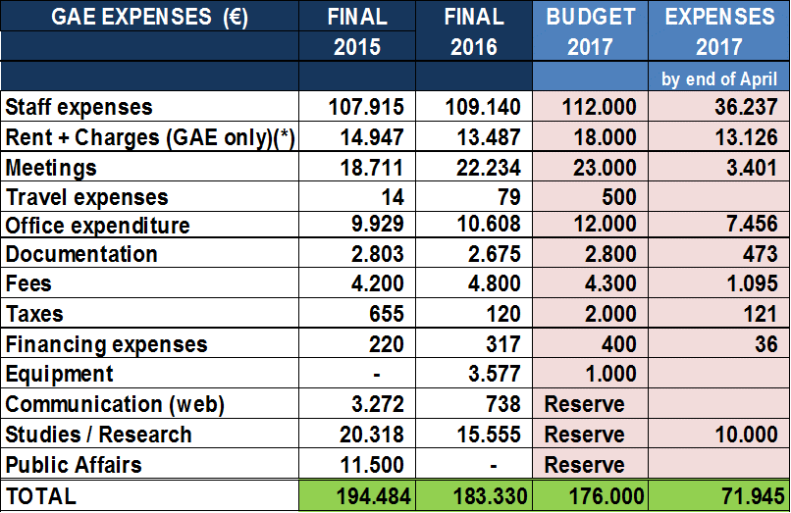

* **AFNOR TC166**

**7. Administration and Next Steps**

1. Following the end of the second year-term of current Executive members, **new elections of Board members** are necessary.
   * **The General Assembly approved the re-election of the following members of the Board (Executive Committee):**

National Representations Mr. Jacques Bordat (France)

Mr. Ezio Borreani (Italy)

Mr. Guy De Clippele (Belgium)

Mr. Dave Dalton (UK)

Mr. Alexander Krissmanek (Austria)

Mr. Johann Overath (Germany)

Mr. Jan Swiatek (Poland)

Sectoral Representations Mr. Bertrand Cazes (Glass for Europe)

Mrs. Adeline Farrelly (Feve)

Mr. Thomas Hünlich (ESGA)

Mr. Xavier Ibled (EDG)

Mr. Axel Jorns (GlassFibreEurope – APFE)

1. At the request of the President not to go forward for another term, Dr Overath and Mr. de Clippele have been approached to become respectively **President and Vice-President** of the association. They agreed to this request.
   * **The members of the General Assembly unanimously approved the nomination of Johann OVERATH as President and Guy de CLIPPELE as Vice-President for a two-year term.**

Members thanked Mr. Jacques Bordat for his excellent job in the association and congratulated Mr. Johann Overath for his new nomination as President and Mr. Guy de Clippele as Vice-President.

Mr. Bordat thanked the Assembly for their support during his 3-year term as President and also congratulated his predecessor and GAE first President, Mr. Paolo Giacobbo, for his contribution to the success of the new structure.

1. Bertrand Cazes confirmed that his Board validated his appointment as **GAE Secretary-General in 2018.**

* **The members of the General Assembly unanimously approved the nomination of Bertrand CAZES as secretary-general in 2018.**

1. **Board Financial Recommendations for 2018**

A **draft working programme for 2018** has been distributed to the members. The Secretary-General explained to the members that this document was elaborated on the basis of the input from the members and the issue leaders, and takes into account the Business Plan 2016-2019. However, more time will be needed to finalise it taking into consideration the future needs of GAE in 2018.

The Working Programme will therefore be presented for discussion to the Executive Committee in autumn, with a view to finalising it by end December 2017.

Regarding the budget and fees 2018, the Executive Committee suggested to find additional measures to reduce the reserve in a more substantial way. The objective is to stabilize the reserve around €75,000. Stability in operational costs and membership fees should however be maintained.

In conclusion, the Executive Committee proposed to validate maximum fees but to determine the final budget at the end of the year, knowing that it will probably be lower than expressed today.

**Draft Maximum Fees 2018**

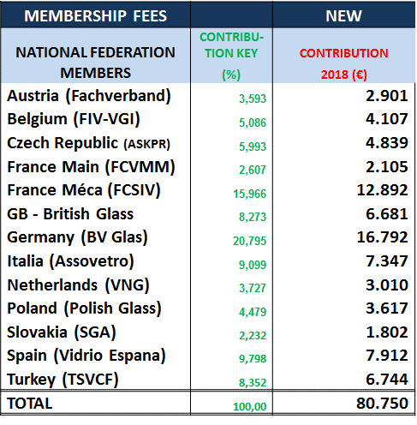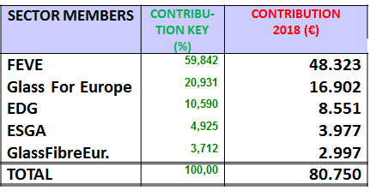

* **The members of the General Assembly approved the suggested procedure (budget principles and cap) and gave a mandate to the Executive Committee to take a final decision on the working programme 2018 and its relevant detailed budget / fees (including measures to progressively reduce the reserve).**

1. **Final Remarks**

* Mr. Škultety invited his colleagues to attend the international Slovak-Czech conference on 29 and 30 June 2017, with a seminar on glass defects, taking place in Trenčin/Teplice (Slovakia). This is also an opportunity to visit the new FunGlass research centre and the tableware company RONA, which is celebrating its 125th anniversary.
* Members thanked Mr. Jacques Bordat for his excellent job in the association and congratulated Mr. Johann Overath for his new nomination as President.

The new President thanked his colleagues for their confidence in this new role and promised to do his best to support GAE.

In the absence of any further item or remark, the President thanked all members for their active participation and closed the meeting.

**_________________________**

GLASS ALLIANCE EUROPE - 89, Avenue Louise Box 5– 1050 Brussels – Belgium

Tel. +32(0)2 538 44 46 - Fax. +32 (0)2 537 84 69 - e-mail. info@glassallianceeurope.eu